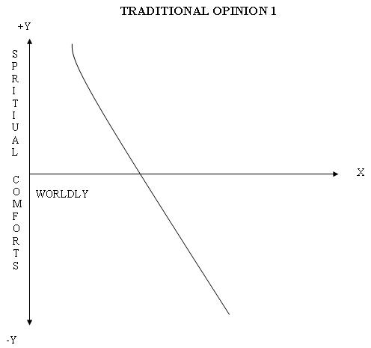
EXPLANATION : As the worldly comforts increase the spiritual comfort comes down thus leading to the increase of sorrow. This is the Traditional opinion of the Indians.
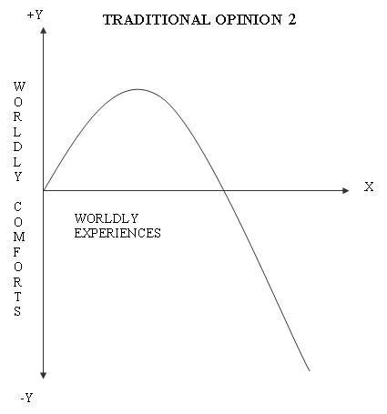
EXPLANATION : As the worldly comforts are experienced, they give happiness only up to some extent and later they also lead to sorrow only ex. Eating sweets, hearing music etc.
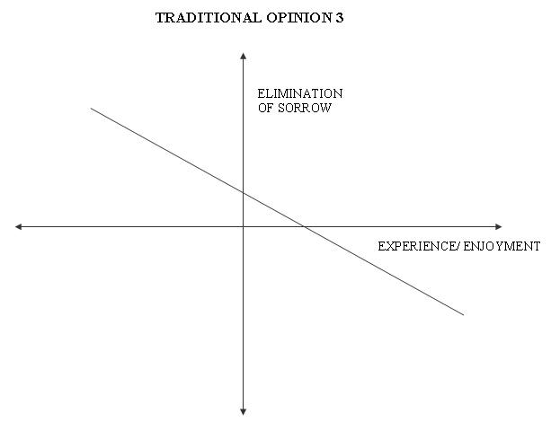
EXPLANATION: The sorrow of a person increases as the worldly experiences/ enjoyment increase. So, the elimination of sorrow is possible by the reduction of the worldly experiences. The negative side of the graph for Y axis ( the elimination of sorrow ) is sorrow itself. The negative X axis ( worldly experiences ) is detachment from the experiences.
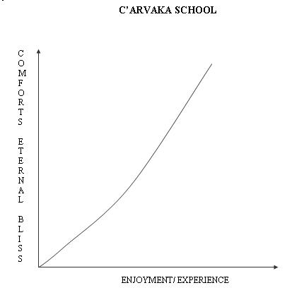
EXPLANATION : C’arvakas opine that the worldly enjoyment/ experience is the final goal and it does give comfort continuously. Although the Moksha is considered as getting rid of the physical body, since there is no true comfort other than physical pleasure, we can understand that only worldly pleasure is the pleasure of Moksha.
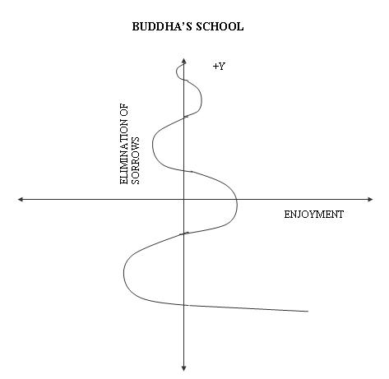
EXPLANATION: Following strict principles and avoiding the worldly pleasures/ enjoyment is the negative side of the enjoyment. The negative side of elimination of sorrow is sorrow itself. The middle path by which partial enjoyment and partial control are observed is the path to achieve Moksha. The pinnacle of removal of the sorrow is Moksha.
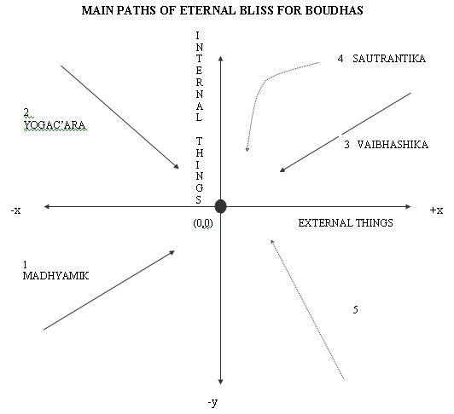
EXPLANATION: Internal things mean accepting the existence of soul etc. It is the positive side of the y axis. Not accepting the same is -ve side. External thhings mean the world etc. Accepting the existence of these things is +ve side of x axis. Not accepting is –ve side.
Origin (0,0) point is the state of emptiness where both external and internal things are non existent.
- Those who reach (0,0) point with the view that both external and internal things are non existent are Madhyamikas.
- Those who do not accept the existence of external things but do accept the existence of internal things to arrive at (0,0) point are Yogac’aras.
- Vais’eshikas are those who reach (0,0) point through the view that both external and internal things do exist.
- Sout’rantikas reach (0,0) point saying that internal things exist whereas the external things are virtual.
- C’arvakas are those who accept the existence of external things but do not accept the existence of internal things. These are shown by dotted line in the 4th quadrant.
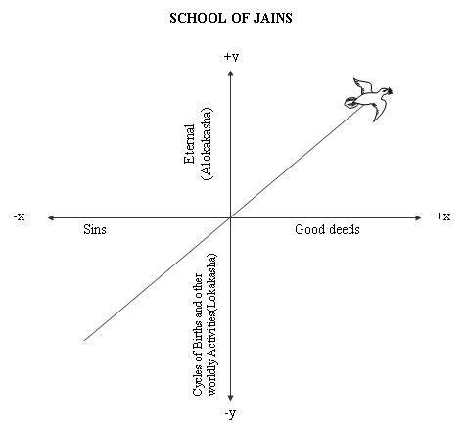
EXPLANATION: Good deeds are good behaviour etc. Sins are opposite of good deeds. Lokakasa is the cycle of births etc. Alokakasa is the bright eternal path for the eternal bliss. As the sinners keep sinking deep into the worldly affairs, the good doers will go upwards like a bird towards eternal bliss.

In terms of similarities, the concept of Nirvana is quite the same between the two. Buddhists believe that Nirvana is a state of freedom. It is when a being turns into a non-being like turning something into nothing. Jainism declares Nirvana as a state of Moksha. The being will tend to lose its identity. In addition, both religions emphasize the practice of meditation and yoga. It is an exercise to focus more on one’s inner self. Yoga is needed for one to be purified and feel liberated. More importantly, the two highlights non-violence.
With regard to their disparities, the foremost difference is on their view on Karma. Although both religions believe in the concept of Karma’s universality, Jainism specifies that Karma is not the effect or result of the person’s actions. Karma is perceived as a true substance that freely flows throughout the human body (jiva). Buddhism concretely believes that karmais the direct effect of one’s own action.The two religions also have differing views about the soul. The soul, according to Jainism is more universal. It is present in all things may it be the living and non-living things. All elements in the universe wind, earth, fire and water also have their own respective souls. Buddhism believes otherwise because the soul is said to reside in living things only like animals and plants and that inanimate objects don’t have any.
Thirdly, the two have different interpretations with the evolution of each person. In Buddhism, the soul will be gone after Nirvana; what’s left is the individuality of the person that passes through a state of nothingness. This state is indescribable. For Jainism, the soul still continues to thrive after Nirvana. This soul remains to be in its purest form and is in its enlightened state.

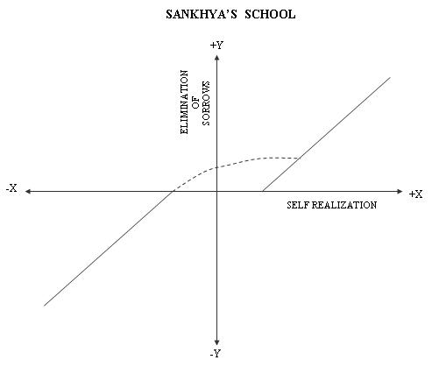
EXPLANATION: Elimination of sorrow means realization that the soul and nature are different. The negative side of this is when the self is fully immersed in the the worldly affairs. As the self realization improves the sorrow is eliminated and the Moksha ( the eternal blliss ) is achieved. As one gets more and more immersed in the worldly affairs the amount of sorrow keeps increasing. We see discontinuity graph above because, the state of realization that soul and the nature are identical and so also both happiness and sorrow becoming zero is only imaginary and not a real state.( by Kapila)

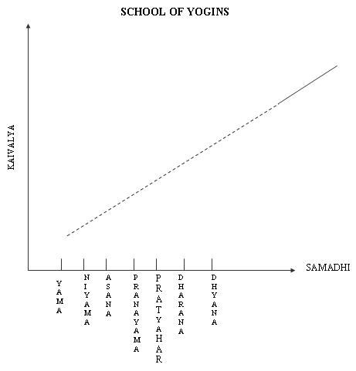
EXPLANATION: The path for Kaivalya starts with Yama, Niyama etc. However, the self realization starts the Dharana and when getting into Dhyana and Samadhi.. Moksha is the eternal goal.( by Patanjali)
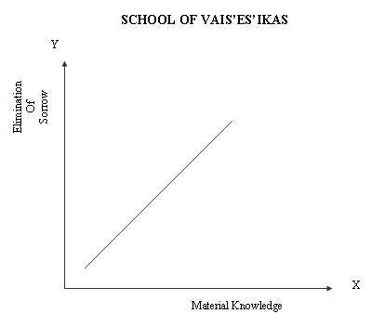
EXPLANATION: The path for Kaivalya starts with Yama, Niyama etc. However, the self realization starts the Dharana and when getting into Dhyana and Samadhi.. Moksha is the eternal goal.
The starting point of the creation is the Will of God. The first product of the Divine Will is Brahma who is the chief architect of creation. Brahma proceeds with further creation in accordance with the totality of the unseen merits and demerits of the individual souls by setting in motion the atoms to combine with one another causing the world. The process of dissolution is in the reverse order where Brahma gives up his body and Ishwara takes charge of the process of dissolution. The whole world is then reduced to the primary state of padarthas.( by Kanaada)

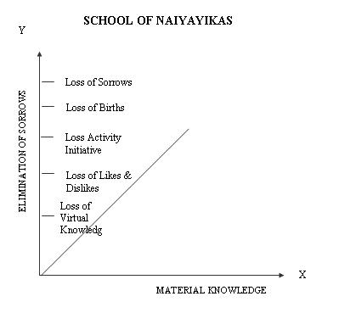
EXPLANATION: Virtual knowledge vanishes due to spiritual knowledge. Then we stop doing any activity. Then no rebirths. Thus the sorrow is eliminated. This is the pinnacle – Moksha.

According to the Nyaya school, there are four sources of knowledge (pramanas): 1. perception (pratyaksha), 2. inference(anumana), 3.comparison (upamana) and 4.verbal testimony (shabda). Knowledge obtained through each of these can, of course, still be either valid or invalid. As a result, Nyaya scholars again went to great pains to identify, in each case, what it took to make knowledge valid, creating in the process a number of explanatory schemes based on pure logic.
(by Gautama)
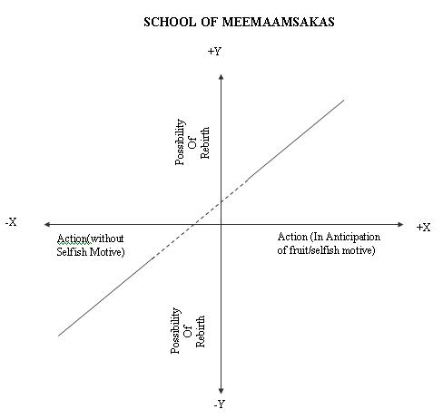
EXPLANATION: Loss of rebirth is Moksha. Negative Y axis moves towards Moksha. Positive Y axis means getting deeper and deeper into the mundane family affairs. Carrying out any action will not stop rebirths because it is not correct to stop action. Carrying out action without any selfish motive and without anticipation of any fruit leads to Moksha. X axis can be indicated as Apoorva & negative end of the Y axis can be called as Moksha. It is not possible to have the zero point on the Y axis and thus it is appropriate to consider the same as two graphs.( by Jaimini)
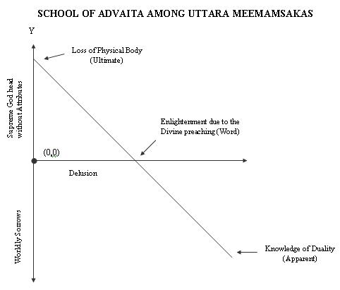
EXPLANATION: Due to Divine ( Great ) Preaching the delusion is removed. However, the experience of the Supreme God Head with attributes and the world is still felt although it is known that they do not exist. Hence, before the Divine ( Great ) preaching these are apparent truths. After the Divine Preaching these are worldly. Once one is devoid of the body these are ultimate truths. The origin (0,0) here indicates the existence of delusion to others even if one is devoid of delusion oneself.( by Aadi Shankara)
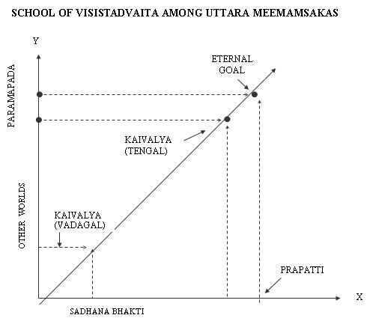
EXPLANATION: Bhakti means thinking of Supreme God Head continuously with love. In any world the happiness is achieved with Bhakti. However the Great Eternal Happiness is possible only at the abode of the Supreme God Head i.e. Paramapada. One achieves it as one’s Bhakti keeps increasing eternally. The pinnacle of Bhakti can lead to Prapatti. Those who do Prapatti may also get Bhakti. However, followers of Prapatti do not have so many stages. It is the abode of Supreme God Head only. For the Vengal cult, the Kaivalya means the nether worlds of Paramapada. For the Tengal cult Kaivalya means the inferior happiness in Paramapada itself. The great Eternal Happiness is one without any mix of sorrow.( by Ramanuja)

